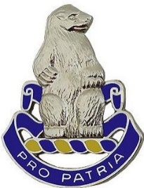**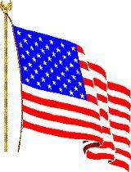ProPatriaPress**

**Newsletter #94**  **February 2020**

**Newsletter of the 31st US Infantry Regiment Association**

***Acting Editor: Ron Corson (jrcorson@aol.com)* _________________________________________________________________________________________**

**MOLINE, ROCK ISLAND, BETTENDORF, AND DAVENPORT - HERE WE COME!**

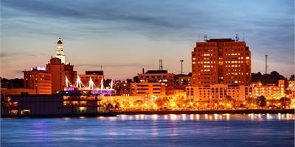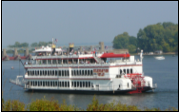The 2020 Reunion of the 31st US Infantry Regiment Association is set. All that is needed now is for the Soldiers, families, and friends of the 31st Infantry to register and join in the fun and camaraderie. The registration form, a listing of the daily events, and a flier that advertises our reunion are in this Newsletter. If you have not put the dates of 19-23 September 2020 on your calendar do it now – That’s kind of like an “Order”. At the Quad Cities of Moline, IL; East Moline, IL; Rock Island, IL; Bettendorf, IA; and Davenport, IA. get ready – **Cause Here We Come!**

**A CHOSEN ONE IS ACCOUNTED FOR - PFC JUNIOR C. EVANS**

The Defense POW/MIA Accounting Agency (DPAA) announced that Army PFC Junior C. Evans, 20, of Hall County, Texas, killed during the Korean War, was accounted for August 7, 2019. In late 1950, Evans was a member of Company I, 3rd Battalion, 31st Infantry Regiment. He was reported MIA on Dec. 12, 1950, near the Chosin Reservoir, likely during a battle between November 27 and December 6, 1950. His remains could not be recovered. On July 27, 2018, after President Donald Trump and North Korean Supreme Leader Kim Jong-un met in June 2018, North Korea turned over 55 boxes purported to contain the remains of American service members. The remains arrived at Joint Base Pearl Harbor-Hickam, Hawaii on August 1, 2018 for identification. To identify Evans’ remains, scientists used anthropological analysis, as well as circumstantial and material evidence. Additionally, mitochondrial DNA (mtDNA) and autosomal DNA (auSTR) analysis was used. Evans’ name is recorded on the Courts of the Missing at the National Memorial Cemetery of the Pacific in Honolulu, along with the others who are missing from the Korean War. A rosette will be placed next to his name to indicate he has been accounted for. Evans will be buried in Gilmer, Texas. The internment date has yet to be determined.

**Highlights in this Edition**

WWII Remains Accounted for - Page 2 The Story of Farrell Lowe Part 2 – Page 2

Leadership in the Confederacy - Page 3 Reunion 2020 Itinerary - Pages 3- 4

Reunion Registration Form - Page 5 31st Infantry’s First Winter in Siberia - Page 6

TAPS and New Members - Pages 7-8 QM Sales Order Form - page 9

**REMAINS OF A WWII SOLDIER ARE ACCOUNTED FOR - SGT JOHN V. PHILLIPS**

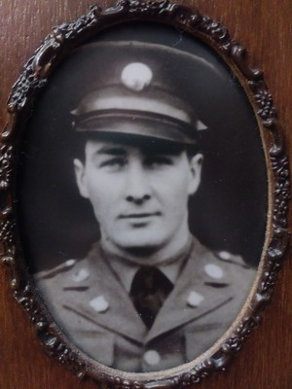 U.S. Army SGT John V. Phillips, 25, of Cassville, Missouri, who was captured and died as a POW during World War II, was accounted for on December 11, 2019. In December 1941, Phillips was a member of HQ Co, 31st Infantry, when Japanese forces invaded the Philippine Islands. Intense fighting continued until the surrender of the Bataan peninsula and Corregidor Island. After the surrender, thousands of Americans and Filipinos were sent to POW camps. Phillips was held at the Cabanatuan POW camp. More than 2,500 POWs perished in this camp during the war. According to prison camp and other historical records, Phillips died July 27, 1942, and was buried along with other deceased prisoners in the local Cabanatuan Camp Cemetery, in Common Grave 225. LTC Brady’s Cabanatuan Roster indicates he died of malaria. Following the war, American Graves Registration Service (AGRS) personnel exhumed those buried at the Cabanatuan cemetery, but not all the remains could be individually identified. These remains were interred as “unknowns” in the present-day Manila American Cemetery and Memorial. In March 2018, remains associated with Common Grave 225 were disinterred and sent to the DPAA laboratory at Joint Base Pearl Harbor-Hickam, Hawaii, for analysis. To identify Phillips’ remains, scientists used dental and anthropological analysis as well as mtDNA analysis. Phillips’ name is recorded on the Walls of the Missing at the Manila American Cemetery and Memorial, an American Battle Monuments Commission site. Although interred as "unknown" in Manila American Cemetery and Memorial, Phillips’ grave was meticulously cared for over the past 70 years by the ABMC. A rosette will be placed next to his name to indicate he has been accounted for. Phillips will be buried at Arlington National Cemetery in Arlington, Virginia. The date has yet to be determined.

THE STORY OF AT ONE TIME THE OLDEST LIVING MEMBER OF OUR ASSOCIATION

Part Two of Five Parts - Composed by Ron Corson; Narrated and Lived by Farrell Lowe

The last edition of the newsletter contained Part One of the story of Farrell Lowe, who was several years ago the oldest living member of our Association who served in the Regiment from 1932 to 1936. I began composing the story after an engaging telephone call with Farrell. Part One ended with Pvt. Lowe receiving an unusually rapid promotion to PFC. The “Chick” Lowe story continues.

PFC Lowe continued his duties in the Regimental Message Center. The “Message Center” was not only the communications center, but also the section that kept and filed Army Regulations, Regimental Regulations/Orders. In late summer of 1935, Chick was promoted to Corporal. Again, at that time in the Army of the 1930’s, that kind of rapid promotion was a very unusual event. CPL Lowe’s work in the Message Center gave him the opportunity to read all kinds of Army Regulations. One that got his attention was one that gave the procedures and rules for Soldiers to apply for a commission as an officer in the US Army Reserve. So, in 1936, Chick completed the paperwork and applied for a commission as 2nd Lieutenant, Infantry Reserve. Chick told me he was certain it was through the machinations of First Sergeant Keyes and the SGM that the unheard of request reached the War Department. Several months later, orders came back from the War Department approving his request, providing that he was conversant with the Manual of Courts Martial and that he could command a Company in close and extended order drilling. Chick had no problem passing the Courts Martial Examination, but he knew that he could never pass command of a Company to the satisfaction of a panel of officers from the Regiment. He had never drilled except at the rear rank of a squad in F Company. In desperation, he requested a transfer from the message center back to F Company where he threw himself on the mercies of First Sergeant Keyes. Keyes laughed and told Chick to tell the Post Adjutant that Chick selected F Company as his demonstration Company. Now in those days, they only “Soldiered” in the morning. The afternoons, as was common with the civilians, were designated for siestas. First Sergeant Keyes turned F Company out one afternoon and informed them of what Chick was trying to do. Apparently, a lot of the members of F Company remembered the “Raw West Point Deal” that Farrell had received as a member of F Company and seemingly welcomed the opportunity to “Show Off”. On the day appointed for the demonstration, Sergeant Major Screen had bleachers erected against the outer walls of the old walled city of Manila near Rizal Plaza. The demonstration company was located across the old sunken gardens approximately 50 yards from the reviewing officers. Another strange thing happened. The 31st Infantry Band had no apparent need of a special drilling, but when F Company appeared it so happened that the 31st Infantry Band was there also to “Practice”. Setting the scene, the band was playing, the flags were flying, the spectators were applauding and F Company with Chick in command but the orders were being given by First Sergeant Keyes and F Company gave a great demonstration at close and extended order drilling. The reviewing officers’ vote was six yes and one no. Several months later, Chick received his order/identification card making him a 2nd Lieutenant of Infantry Reserves. However, remember in those days active duty was active duty and holding a commission in the Reserve Army still made you just a CPL on active duty. And so ends Part Two of the Chick Lowe story - to be continued.

**Leadership in the Confederate Army**

From “The Fremantle Diary: Being the Journal of Lieutenant Colonel Arthur James Lyon Fremantle, Coldstream Guards, on his Three Months in the Southern States.”

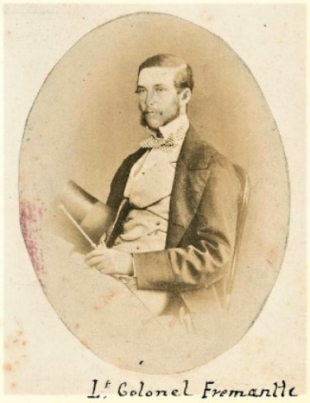

During the first half of 1863, Lieutenant Colonel Arthur Fremantle of Britain’s Coldstream Guard rode for three months with Confederate Forces. He was present at the Battle of Gettysburg. This excerpt is from the June 2, 1863 entry in his diary:

*Colonel Grenfell told me that the only way in which an officer could acquire influence over the Confederate soldiers was by his personal conduct under fire. They hold a man in great esteem who in action sets them an example of contempt for danger; but they think nothing of an officer who is not in the habit of leading them. In fact, such a man could not possibly retain his position. Colonel Grenfell’s expression was, “every atom of authority has to be purchased by a drop of your blood.”* Seems that Soldiers have known for some time that “Leaders” lead from the front!

REUNION 2020 - QUAD CITIES – SEPTEMBER 19-23

**ITINERARY FOR REUNION 2020 - 31ST US INFANTRY REGIMENT ASSOCIATION**

**DAY ONE: Saturday 9/19/2020**

*12:00-17:00: Registration open. Lobby. 2nd Floor Conference Center & QM Store Open Salon 1 2nd Floor.*

*12:00-17:00: Association Hospitality Room open. Retreat Room. 2nd Floor Conference Center.*

*16:00-20:00: Visit Quad Cities info booth Hallway 2nd Floor.*

*16:00-21:00: Dinner and time to explore on your own.*

**DAY TWO: Sunday 9/20/2020**

*07:00-09:30: Breakfast Served in the Rock Island Ale House.*

*10:00-11:00:* ***31st Infantry Memorial Service****. Salon 1 & 2. 2nd Floor Conference Center.*

*11:00-21:00: Association Hospitality Room open. Retreat Room. 2nd Floor Conference Center.*

*11:30-13:30: Lunch and time to explore on your own.*

*17:30-20:30: Welcome Cocktail Reception.& BBQ Dinner - Grand Ballroom. 2nd Floor Conference Center.*

**DAY THREE: Monday 9/21/2020**

*07:00-09:30: Breakfast Served in the attached Rock Island Ale House.*

09:00: *Association Hospitality Room opens. Retreat Room. 2nd Floor Conference Center.*

09:00-12:00: *Registration Desk & Welcome Table open. Lobby. 2nd Floor Conference Center.*

*09:00-10:30: General Membership Meeting. Salon 3. 2nd Floor Conference*

*Center.*

*11:00-13:00: Lunch on your own.*

 

*12:30-16:30: Rock Island Arsenal Tour. Meet in Lobby on the first floor by 12:15.*

*15:00-15:30:* ***Raffle Drawing & Silent Auction Final Hours***

*Registration Table.2nd floor Conference Center.*

*17:00-21:00: Celebration Belle Caption & Dance Cruise. Meet at dock by 16:30*

*Address: 2501 River Drive Moline, IL 61265.*

**DAY FOUR: Tuesday 9/22/2020**

*09:00-11:00: John Deere Pavilion & Store. Meet at JDP by 8:45.*

*Address: 1400 River Drive Moline, IL 61265.*

*17:30: Reception and Cocktails – Grand Ballroom 2nd Floor Conf Center*

*18:30: Posting of the Colors & Invocation, Dinner and Guest Speakers*

*. Grand Ballroom. 2nd Floor Conference Center.*

*20:30-22:00: The Shanghai Bowl Ceremony and Formal Toasts to the 31st US*

*Infantry Regiment. Grand Ballroom. 2nd Floor Conference Center.*

**DEPARTURE DAY: Wednesday 9/23/2020**

*09:30-Whenever: The Goodbyes.* ***See you at the next Association Reunion!***

Place and dates TBA based on member votes and changes to the Association Constitution. Stay tuned!

Unless noted all evening activities, off-site activities and Company Dinners are on your own.

Free time can be used for exploring the area or for Unit Dinners.

**REGISTRATION FORM REUNION 2020** - **Rock Island, IL**

**31st US Infantry Regiment Association**

**Sept 19-23, 2020**

Name: _______________________________________________________________________________

Guest(s): _____________________________________________________________________________

Home Street Address: __________________________________________________________________

City: ______________________________________ State: _____________ ZIP Code: ______________

E-mail: ________________________________________ Phone: _______________________________

Company & Battalion of the 31st Infantry: ________________________ When: __________________

If active duty, Current Rank: __________________ Post stationed at: ___________________________

Served in Combat Zone: Yes / No (Circle) If Yes, where: _________________________________

Will you be staying at Holiday Inn Rock Island Yes / No (Circle)?

Have a car at the reunion? Yes / No If needed, are you willing to assist in local driving? Yes / No

**Reunion Activity Cost per Person X # Participating = Event Cost**

Reunion Registration $40 x _______ $ _________

Reunion Arrival Dinner $27 x _______ $ _________

Rock Island Arsenal Tour $15 x ________ $__________

Celebration Dinner Cruise $60 x ________ $__________

Reunion Banquet $40 x _______ $__________

John Deere Factory Tour $15 x _______ $__________

**Grand Total** **$ __________**

Make checks payable to**: 31st US Infantry Regiment Association Attn: Joe DeAngelis 3035 El Rio Dr Meridian Idaho 83642**

**Hotel and Travel Information: Total Cost is $85.00/night including tax and a Hot Breakfast every morning**

**Holiday Inn & Conference Center Quad City International Airport (MOL)**

**226 17th Street**  **Free airport / Hotel Shuttle**

**Rock Island, IL 61201** Moline Airport serviced by all major carriers. **www.holidayinn.com/rockisland**

**Reserve Room at (309-794-1212)**

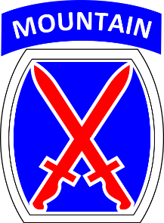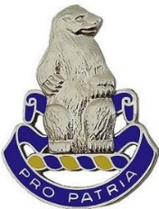

**What’s Happening in the 4th Battalion**

Right after 4-31 returned to Fort Drum from its deployment to Afghanistan, the unit was busy taking care of garrison business with Soldiers departing and new Polar Bears arriving, getting equipment squared away, and giving the Soldiers some well-earned time off. In November the, battalion celebrated its return with a battalion formal and then there was the Christmas schedule and a chance for many Polar Bears to have some time at home. But like any good unit, in January combat skills training was the order of the day. As of 31 January, the battalion completed day and night platoon live fire tactical exercises to hone platoon level tactical skills (fire and maneuver) under simulated combat conditions. The next months will bring more tough training, but for now, as HQ elements of 10th Mountain Division and the 1st Brigade begin a deployment to Afghanistan, 4-31 Infantry has no combat deployments on its schedule. Pro Patria - The Polar Bears of the 4th Battalion.

**The 31st Infantry’s First Winter in Siberia**

(taken with editorial changes from The 31st Infantry Regiment A History of “America’s Foreign Legion” – pages 29-30)

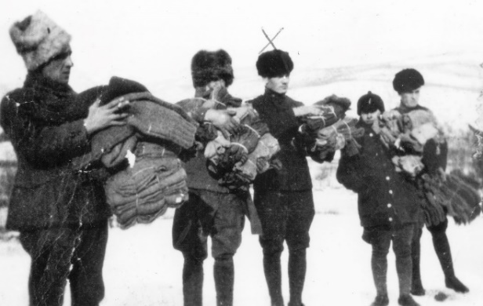The first three months of 1919 were extremely cold, but US Army winter clothing was surprisingly suitable for Siberia’s climate. It consisted of a woolen shirt, woolen trousers, a woolen jacket, a three-quarter length sheep-lined overcoat, muskrat cap, muskrat gloves, and heavy four-buckle overshoes. In the picture to the right Alf Thompson is in the middle of this photo taken in the winter of 1919. Troops were armed with an M1903 Springfield rifle, an M1918 Browning Automatic Rifle (BAR), or an M1911 .45 caliber pistol, depending on their duties. All of those were still new at the time, representing the state of the art in infantry weapons. Soldiers who fought in Korea 30 years later would still be using the BAR and the trusty .45 caliber pistol would remain in service into the 1990s. The regiment’s heaviest weapons were three horse-drawn 37mm field guns with a range of up to 2500 yards. Each was served by a two-man crew.

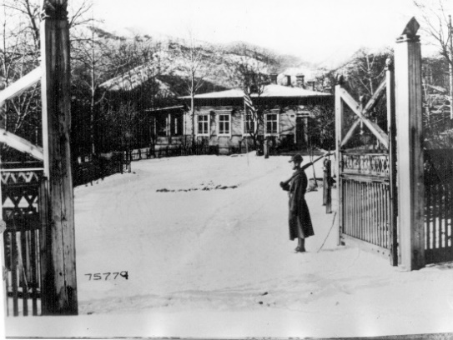The picture at the left below shows an American Soldier guarding the front gate of the allied Mine Detachment HQ. During the Siberian deployment, disease became a major issue for 31st Infantry Soldiers. In the early 1900s, sources of contagious diseases were becoming better understood, but gaps in medical and sanitation knowledge still left soldiers vulnerable to a wide variety of deadly germs. An influenza epidemic swept the world in 1918, killing over twenty million people, including thousands of American soldiers. Twice in the early months of 1919, Headquarters Company was quarantined due to outbreaks of spinal meningitis. Among those stricken was Carl Boling, the regiment’s Sergeant Major. Each time a case of influenza occurred in Vladivostok; everyone feared the worst. During the regiment’s service in Siberia, 59 of its members would succumb to disease or non-battle injuries.

**TAPS**

**Deceased members identified since Newsletter # 92, March 2019**

**World War II**

Curtis G. Davis, unkn, Burlington, NC, died June 7, 2009, unit unkn, 1941 - 1945

Joseph Q. Johnson, SGT, Sun City West, AZ, died Jun 24, 2017, Co D, 1st Bn, 1941 - 1945

**Pre-Korean War**

Robert J. Billeter, PFC, Weston, WV, died Nov 30, 2019, Cos E & HHC, Bn, 1946

Robert L. Hamilton, PFC, Sheldon, IA, died Apr 27, 2019, unit unkn, 1946-47

Robert G. Loundagin, PFC, Pleasanton, CA, died May 7, 2004, G Co, 1st Bn, 1947

Leo C. Simms, TSGT, Madison, WI, died Apr 17, 2011, Svc, Rgt, 1947 - 1949

John E. Topa, PFC, Michigan City, IN, died Mar 18, 2019, Anti Tk, Regt, 1946 - 1947

Glenn H. Wemple, PFC, Milford, CA, died Feb 17, 2017, Co I, 3rd Bn, 1946

**Korea War**

Robert F. Christman, CPL, New Hyde Park, NY, died Jun 7, 2018, Cos C & Svc, 1st Bn, 1953 - 1954

John J. “Jack” Considine, CPL, Torrington, CT, died May 25, 2019, Co B, 1st Bn, 1952 - 1953

John F. Dooley, unkn, Caledonia, MI, died Jan 8, 2009, unit and period unkn

Donald N. Escott, PFC, Tampa, FL, died Nov 15, 2019, HHC, 2nd and 3rd Bns, 1949 - 1951

Robert D. Fenstemacher, PFC, Chaplin, MN, died Oct 22, 2017, 57th FA, 1952 - 1953

James R. Hickey, Dr., SGT, Ettrick, WI, died Apr 1, 2019, Co G, 2nd Bn, 1952

John R. Jarvis, CPL, Arnold, MO, died Mar 22, 2019, Co G, 2nd Bn, 1951 - 1952

Donald M. Lesch, CWO, Ocala, FL, died Oct 9, 2018, Hq, Rgt, 1952

Charles A. Lonsford, MAJ, Sheridan, OR, died Aug 31, 2016, unit unkn, 1950

Edward J. Prem, PFC, Loganville, WI, died May 12, 2019, Co I, 2nd Bn, 1952 - 1953

Peter Rivenburg, CPL, Reno, NV, died Jul 6, 2007, Co A, 1st Bn, 1953

Daniel L. Royse, SGT, Columbia, KY, died Sep 15, 2006, unit unkn, 1953

Bevan H. Toneri, CPL, Marysville, WV, died Sep 22, 2019, HHC, Rgt, 1952 - 1953

Richard C. Vallowe, CPL, Belleville, IL, died Mar 19, 2019, 57th Field Artillery, 1949 - 1950

**Correction in NL 91 TAPs**

**Fredrick H. Walters**, Cambridge City, IN, died Oct 20, 2016, Co I, 3rd Bn, period unkn

**Post Korean War**

Ernest A. Manerchia, Jr., SGT, West Grove, PA, died Jan 17, 2017, HHC, 1st Bn, 1986 - 1987

**Vietnam**

Charles E. Barr, Sr., SGT, Lyons, IL, died Mar 14, 2018, Co D, 6th Bn, 1968 - 1969

Donald W. Bellinger, SGT, Logsden, OR, died Oct 10, 2019, Co D, 6th Bn, 1968 - 1969

Richard A. Carruthers, SGT, Napa, CA, died Jun 27, 2015, Co C, 6th Bn, 1970

Cecil M. “Hank” Henry, COL ret, Corpus Christi, TX, died Jan 8, 2019, Cdr, 4th Bn, 1969

Harry L. Lower, SGT, Mount Vernon, WA, died unkn, Co D, 6th Bn, 1969 - 1970

William B. McMullen, SP4, Wellington, FL, died Feb 12, 2019, Co C, 6th Bn, 1968 - 1969

Bryan McMullen, Anchorage, AK, died Nov 16, 2018, son of William McMullen, 6th Bn

Orville “Mike” Pentico, SFC ret, Crocker, MO, died Nov 1, 2016, Co B, 6th Bn, period unkn

James D. Quisenberry, MAJ ret, Louisville, KY, died Sept 6, 2018, Cos A & D, 6th Bn, 1967 - 1969

**Vietnam and Korea**

Floyd B. Brooks, SFC, Gastonia, NC, died Aug 19, 2003, Co L, 3rd Bn, 1952 - 1953,

Co A, 4th Bn, 1966 - 1967

**Associate**

Ruth E. Reagan, Jenks, OK, date died unkn, husband, unit and period unkn

**\*\*\***

**NEW MEMBERS**

**Life Members**

David M. Atwood, MAJ ret, Moravia, NY, HHC, 1st Bn, Korea, 1984

Albert ”Al” J. Kramer, PFC, Spring Hill, FL, Co D, 2nd Bn, Korea, 1958 – 1960

Kenneth C. Robinson, SP4, Haslet, TX, Co B, 4th Bn, VN, 1966 - 1967

**31st INFANTRY REGIMENT ASSOCIATION QUARTERMASTER STORE ORDER FORM**

***Visit 31stinfantry.org and click on 31st Infantry Store to see a full color catalogue of these and many more items***

**Name:________________________________________________ Telephone #____________________________________________**

**Address:_____________________________________________________________________________________________________**

**City:_______________________________ State:_____________ Zip:___________ Email:__________________________________**

**Cat # Description ­_____________ Price Qty Total**

**B 102 Book, 31st Infantry Regiment “America’s Foreign Legion” In peace and war(Includes shipping)**

**Do not include this in shipping cost at bottom of form $ 40.00 X___=________**

**C 100 Coin, Commemorative, 100th Anniversary (if you order 10 or more the price is $8.00 each). $ 10.00 X___=_______**

**C100AT Air Tight capsule for 100th Anniversary Commemorative coin $ 1.50 X___=_______**

**C100EB Easel, black *both the black and clear easels are for Air Tight capsule with 100th* $ 1.50 X___=_______**

**C100EC Easel, clear *Anniversary Commemorative coin or the Commemorative coin alone* $ 1.50 X___=_______**

C RB 02 Cap, **Royal Blue**, 31st INFANTRY REGIMENT, POLAR BEARS, and crest embroidered directly $ 15.00 X ___=_______ directly on cap and US ARMY embroidered on back.

C RB Cap same as C RB 02 above with the addition of a waving U.S. flag on the left side and a combat

patch (Philippines Division; 7th Infantry Division; 196 Light Infantry Brigade; 9th Infantry Division;

10th Mountain Div) on the right side. **Circle the patch you want.** $18.00 X___=_______

C K ***NEW CAP!*** same as C RB above but in **Khaki** with a waving U.S. flag on the left side and a combat patch

*(Philippines Division; 7th Infantry Division; 196 Light Infantry Brigade; 9th Infantry Division;*

*10th Mountain Division)* on the right side. **Circle the patch you want**)**.** All embroidery is subdued. $18.00 X___=_______

SP Shirt, Polo/golf w/31st INFANTRY REGIMENT and polar bear crest on left chest, **no pocket**

**Please circle color and size.** Size S, M, L, XL White, Light Blue, Navy Blue $ 29.00 X___=_______

Size 2XL White, Light Blue, Navy Blue $ 31.00 X___=_______

**SP100 Same as above with 100th Anniversary logo in White only Size: S**, ~~M~~ (Sold out), **L, XL $ 31.00 X___=_______**

**Size: 2XL $ 33.00 X___=_______ Size: 3XL $ 35.00 X___=_______**

ST Shirt, Tee, w/31st INFANTRY REGIMENT and polar bear crest on left chest, **no pocket**

**Please circle color and size.** Size S, M, L, XL Light Blue, Navy Blue $ 16.00 X___=_______

Size 2XL Light Blue, Navy Blue $ 19.00 X___=_______

Size 3XL Light Blue, Navy Blue $ 21.00 X___=_______

SLSVC Shirt, Long Sleeve, Dress in various colors w/31st INFANTRY REGIMENT and polar bear crest on left chest above pocket.

**Please circle color and size.** Size S, M, L, XL $ 30.00 X ___=_______

Colors: Black, Navy Blue, Light Blue, Red, White, Texas Orange, Burgundy, Size 2XL $ 32.00 X___=_______

**or Denim** Size 3XL $ 36.00 X___=_______

MS 01 Shanghai Bowl Cup, silver, 2007 reproduction of original. (Includes shipping)

**Do not include this in shipping cost at bottom of form** $165.00X___=_______

DCL 01 Bumper sticker, 31st Infantry crest (Polar Bear), 4-3/8” tall, 4-1/4 wide $ 3.00 X___=_______

PN 01 Pin, 31st Infantry Regimental crest (Polar Bear) , regulation size, facing set. $ 8.00 X___=_______

PN 02 Pin, 31st Infantry Regimental crest (Polar Bear) , lapel/hat pin. 7/8” tall, ¾” wide $ 4.00 X___=_______

PN 73 Pin, Combat Infantry Badge, lapel/hat pin. 3/8” tall, 1-1/4” wide $ 3.00 X___=_______

PN 74 Pin, Combat Infantry Badge, regulation size, 1-1/4” tall, 3” wide $ 4.00 X___=_______

PN 82 Pin, Purple Heart, lapel/hat pin. 1-1/8” tall, 5/8” wide $ 3.00 X___=_______

PN 85 Pin, Silver Star, lapel/hat pin. 1-1/8” tall, 5/8” wide $ 3.00 X___=_______

PN 71 Pin, Bronze Star, lapel/hat pin. 1-1/8” tall, 5/8” wide $ 3.00 X___=_______

**SUBTOTAL $_________**

**Shipping Charges** – add to your order: Orders under $10.00 add $2.50; For orders $10.01 - $25.00 **$_________**

add $6.00; For orders $25.01 - $50.00, add $7.00; For orders over $50.00, add $9.00. **SHIPPING** (prices at left) **$_________**

**Grand TOTAL $_________**

MAKE CHECK OR MONEY ORDER PAYABLE TO: **31ST INFANTRY REGIMENT ASSOCIATION**

**For Credit Cards (American Express, Discover, Master Card, or Visa) or Debit card (with Master Card or Visa logo)** please include

**NAME** (on card):___________________________________ **CARD #:________________________________EXP DATE:_____/_____**

**SECURITY CODE**(on back of card): ____________ **ZIP CODE** (where credit card bill is mailed to):_____________________

**Mail the order form and payment to**: **Dale Mills 337 Carillon Lane, Macon, GA 31210-9711**

**Association Officers**

**Honorary Colonel of the Regiment Robert “Sam” Wetzel LTG Ret** (LTC, 4th Bn, VN 1968)

1425 Dartmouth Rd, Columbus, GA 31904 706-576-4204 wiint322@aol.com

**Commander**: **Charlie Tapp** (SGT/D/6thBn, VN, 1968-69)

215 Waterford Drive, Inman, SC 29349 864-473-1999 ctapp94@$mail

C 864 680-9165

**Vice Commander**: **Dan Wood** (CSM/4th Bn, Ft. Drum, 2000-02)

1484 McGill Road, Vass, NC 28394 910-633-8397 wooddr3@gmail.com

**Adjutant**: **Vin Zike** (SGT,D/6th Bn, VN, 1969-70)

3036 Park Ave, Apt. 3, Rivera Beach, FL 33404 914-850-0095 vinzike@gmail.com

**Treasurer: Joe DeAngelis**  (SGT,C/6thBn,Ft Lewis & VN, 1967-69)

3035S. El Rio Dr., Meridian, ID 83642 208-362-9468 jangels10@gmail.com

**Membership**: **Jim Tierney**  (SSG, A/6th Bn, VN, 1969-70)

1484 Loretta Dr., Penn Hills, PA 15235 412-793-7214 jtier64999@aol.com

**Quartermaster**: **Dale Mills** (SGT,C/6thBn,VN,1968-69)

337 Carillon Lane, Macon, GA 31210-9711 478-787-2679 sdalem@bellsouth.net

**Sergeant at Arms**: **Jim Jaggers** (SGT, D/6th Bn, VN1 969)

5638 Camellia Ave, Sacramento, CA 95819 916-455-7879 jim@jaggers.me

**Historian: Grady Smith** (CPT, D/6th Bn, Ft Lewis & VN, 1967-68)

2321 S. Queen St, Arlington, VA 22202 703-769-2778 smithga@verizon.net

C 703 927-6161

**Senior Director: Ron Corson** (CPT, A/6th Bn, VN, 1969-70)

108 Mershon Way, Williamsburg, VA 23185 757-253-1311 jrcorson@aol.com

**Northeast Region (**ME, NH, VT, MA, RI, CT, NY) **Ivan Barker** (1st SGT,F/HHC/4th Bn, Ft Drum, 2012-17)

3127 Cataract St, Copenhagen, NY 13626 315-286-7696 barker_ivan@hotmail.com

**Mid-Atlantic Region** (NJ, PA, DE, MD, DC, VA, WV) **Jim Simms** (LT,HHC &C/4thBn,VN,1969-70)

104 Cumberland Dr., Carlisle, PA 17013 717-243-5570 jnpsim@comcast.net

**Southeast Region** (NC, SC, GA, FL, AL, MS, TN, AR, LA, PR, VI) **Noah Halfacre** (LT,E/6thBn,VN, 1968)

2740 Oxford Hall Ave, Murfreesboro, TN 37128 615-892-9715 gimlet3a@gmail.com

**Great Lakes Region** (KY, OH, MI, IN, IL, WI) **John Howdeshelt** (SGT,D/6th Bn,VN,1969)

788 Eagledale Circle, Kettering, OH 45429 937-435-0669 mamahowdy@yahoo.com

**Midwest Region** (MN, ND, SD, NE, IA, MO, KS, OK, TX, NM, CO) **John Mansfield** (LT, A&B/4th Bn, VN 1968)

3100 Chambers St, Sioux City, IA 51104 712-277-4498 arctic6@aol.com

**Western Region** (HI, AK, WA, OR, CA, NV, AZ, UT, ID, MT, WY) **Ron Belloli** (LT,C/6thBn,VN,1967-68)

1250 American Pacific Dr, Apt 214, Henderson, NV 89074 928-380-9577 ronbob22631@gmail.com

**. . . . . . . . . . . . . . . . . . . . . . . . . . .**

**NEWSLETTER CHANGE OF ADDRESS**

Cut along dotted line. Fill in requested information and mail to James Tierney, Membership Chair, address below.

or EMAIL Jim Tierney with this information at jtier64999@aol.com **Subject: Change of Address**.

Name: ________________________________________ Phone number if new: ______________________________

Old Address New Address Mail To:

___________________________ __________________________ **JimTierney, Membership Chair**

Street or P.O. Box Street or P.O. Box **1484 Loretta Drive**

___________________________ __________________________ **Penn Hills, PA 15235**

City/State/Zip City/State/Zip

**Membership Application – 31st US Infantry Regiment Association**

First Name Nickname Middle Initial Last Name

Street Address City State Zip Code Phone Number

E-mail address Alternate E-mail Address

Please fill in as much information about your service/connection with the 31st Infantry Regiment as possible:

Platoon__________ Company Battalion

________

Highest Award Earned

Rank & Duty Position when serving with the 31st Regiment Rank When Retired/Separated

**Where did you serve with the 31st? When?**

Philippines __________ _______________________________________

Japan __________ _______________________________________

Korea __________ _______________________________________

Vietnam __________ _______________________________________

Iraq __________ _______________________________________

Afghanistan __________ _______________________________________

Other Overseas __________ _______________________________________

USA __________ _______________________________________

**Membership Desired**

**Life Membership Annual Membership per Year**

Active Duty __$25 Current Active Duty Member __$5

Age 49 & under __$60 Prior Member of 31st Unit __$10

Age 50 – 59 __$45 Associate Member (family) __$5

Age 60 & over __$35

Associate Life __$25

Member (family)

Make your check out to **31st Inf Regt Assn** and mail it to our Membership Chairman: **Jim Tierney,**

**1484 Loretta Drive, Penn Hills, PA 15235.**

**31st Infantry Regiment Association**

**Jim Tierney**

**1484 Loretta Drive**

**Penn Hills, PA 15235**

**Newsletter 94**

### RETURN SERVICE REQUESTED

**Time to Mark Your Calendars**

**For Reunion 2020 at the Quad Cities along the Mississippi**

 **19 to 23 September 2020**